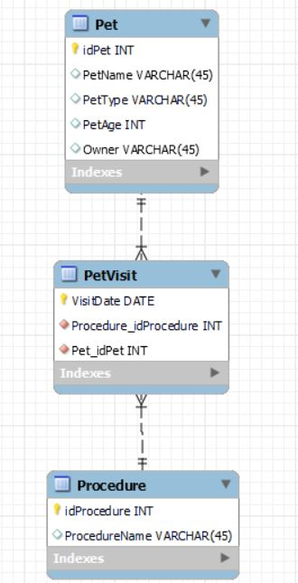

Using MySQL Workbench Data Modeler, create a model showing the below table in 3rd Normal Form.  Note that you only can model table and column names and data types.  The data shown is for your reference to determine functional, partial, and transitive dependencies.

